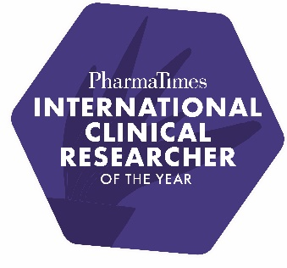
PharmaTimes International Clinical Researcher of the Year 2026
Stage 2 Challenge – Start Up Singles

"The Functional Service Provider (FSP) Acceleration Challenge"

The biopharmaceutical industry is transforming as the external environment changes due to regulatory requirements, technology changes, macro-economic conditions and more, and therefore it is critical that the correct outsourcing model is selected to optimise drug development cost and time to market. Customised models can enhance collaboration, innovation, knowledge sharing and shared ownership of goals compared to some full-service models.

In your new role as “FSP Site Activation Manager/SSU lead”, the sponsor says to you "We chose FSP expecting streamlined processes and faster timelines. Our current 8-month activation timeframe is the same as traditional CROs delivered. Can you cut this to 6 months and show us the real FSP advantage?"

Consider the process steps, team structure, communication and escalation pathways and all potential bottlenecks in your previous full-service role and consider how the FSP model can streamline processes and enhance start up timelines.

Your challenge is to deliver a 3-step acceleration plan with timeline targets and specific FSP advantages leveraged.

Please provide your answers in the format of an A1 size poster. To do this, open PowerPoint, go to Design, select Slide Size, then Custom Slide Size and enter in 59.4cm by 84.1cm and select Landscape. This will then give you an A1 size slide to work on.

Please do not use Generative AI tools as these entries will be excluded from the competition where suspected or identified.

Please do not refer to your name or company within your submission. Your entry should be anonymised.
================================================================================

Completed challenges to be sent to: debbie.tuesley@pharmatimes.com by 23rd January and your covering email must include:

Name: Job Title:

Company: Email:

Category Entering: Telephone (include country code):

Entrant’s country (if a team, the country for the team leader):

The Clinical Singles finals will be on the 20th March 2026. Please keep this date available. Thank you

